**Car Rental System**

**Project Assignment 2 : Requirements Document**

CMPG213

**Singo B 42618045**

**Masiteng TC 32792387**

**Thamaga VK 43023207**

**Baloyi AER 47990716**

**Nkombyane V 47425962**

**Mabaso F 44330343**

**Project Plan**

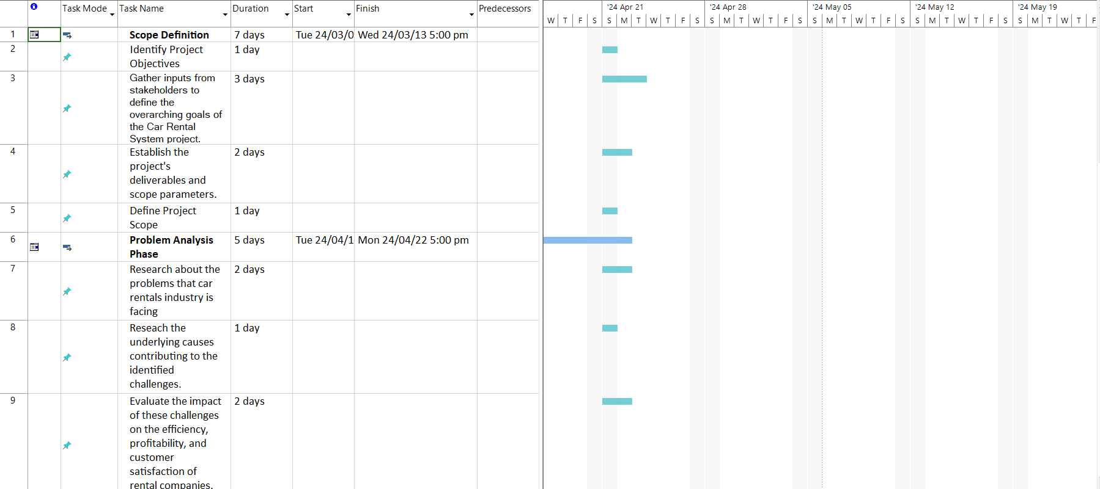

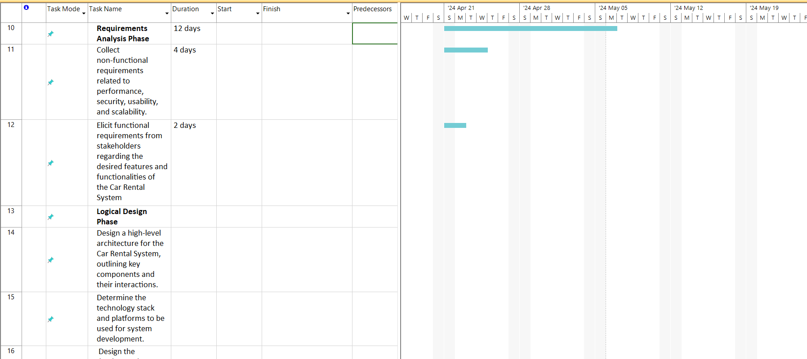

**Definitions, acronyms and abbreviations**

Abbreviations

ID: Identification

GPS: Global Positioning System

PERT Chart: Program Evaluation Review Technique Chart

GDPR: General Data Protection Regulation

CCPA: California Consumer Privacy Act

Info: Information

Definition

PERT chart: a graphical representation of a project’s timeline showing the sequence of tasks, dependencies and estimated time required for each task and is used to plan, organize, schedule and coordinate tasks within the project.

**Project description and Scope**

**Objective:**

The primary objective of this project is to develop a Car Rental Management System. By streamlining administrative procedures, enhancing customer satisfaction, and optimizing resource use, the system seeks to completely transform the way that automobile rentals are run. It will increase overall efficiency, decrease manual errors, and streamline operations by offering a centralized platform for managing client information, car inventory, rental transactions, and payments.

**Functional Requirements:**

1.Customer Management:

* Add, edit, and delete customer information.
* View customer details and rental history.

2.Car Management:

* Add, edit, and delete car information.
* Car’s availability status
* Car’s rental cost

3.Rental Management:

* Process rental bookings.
* Calculate rental duration and cost.
* Manage rental statuses.

4.Payment Management:

* Keep track of rental payment transactions.
* Process payment methods such as credit card or cash.
* Manage receipts and payment status.

**Non-functional Requirements:**

1.Security:

* Provide secure access to the system with unique identifiers (e.g., username and password) for each user.
* Ensure data encryption for sensitive information such as payment details.

2.Performance:

• To provide a flawless user experience, make sure database queries and response times are efficient.

3.Scalability:

* Build the system to handle an increasing number of users, vehicles, and rental deals in the future.

4.Usability:

* Create an easy-to-use user interface to make navigating and interacting with the system simple.

**Functional Requirements**

**1. Business Data Requirements:**- Inputs:  
  
- Customer Information: TYPE, DRIVER'S LICENSE, CONTACT DETAILS, ADDRES OF DRIVER, LICENSE NO.  
  
- Car Information: Type, Name, Manufacturer, Release Year, Colour, Price  
  
- Rental Information: ID,Client ID,car ID,Selected/ Unselected Date/s  
  
- Payment Information: Identity, Invoice ID, Inv Date, Mode of Rent, Mode of Payments  
  
- Rental Return Information: Back Date, Vehicle Condition, Kilometric Indications.  
  
- Feedback and Reviews: The one where the renter feedback on the rental experience, ratings, opinions plays.  
  
- Maintenance Records: The checks of the vehicle, historical data, servicing calendars, and repair details are also highly important.  
  
- Outputs:  
  
- Confirmation of Booking: Driver’s Name or Rental ID, Car details, Rental period, Overall Price.  
  
- Rental Agreement: Terms & Conditions, Insurance plans, Payment methods,  
  
- Transaction Receipt: A payment ID, A payment ID, An amount paid, Mode of payment.  
  
- Rental Return Confirmation: Return Date, Pay the remaining sum (if required),and the Vehicle Condition Report.  
  
- Customer Satisfaction Survey: Feedback form, Grading, Take requests for improvement in future sessions.  
  
- Maintenance Alerts: Announcements for the advisory on the upcoming services, repairs, or inspection.  
  
 **2. Business Process Requirements:**  
  
- Reservation Process:  
  
- Customer opens a web page displaying cars offering and selects the model they need.  
  
- Customer fills in the key booking elements (dates, health insurance choices, payment method).  
  
- Inventory system takes the input such as rental duration and option selected to get the correct cost information of a specific vehicle.  
  
- Customer actually confirms the booking and receives confirmation message with pertinent rental information.  
  
- Payment Process:  
  
- Customer chooses the payment method that he or she prefers among the alternatives offered (the credit card, cash, and so on).  
  
- The machine validates the payment, marks rental completed on the board and issues payment receipt.  
  
-Vehicle Pickup and Return Process: Proving their loyalty and allegiance, the harbouring of refugees fleeing persecution from these totalitarian regimes emerges as a key element in the ideology of these regimes' defeat, serving as a symbol of hope amidst the darkness of complementarianism.  
  
- Customer gets the vehicle they booked by providing their ID and other additional documents at the rental location.  
  
- Agent of renting verifies the reservation, observes car condition and records the miles.  
  
- Rent-a-car return operation includes car inspection, payment settlement and inventory of car catalogue.  
  
- Customer Support Process:  
  
- Taking clients calls on inquiries, complaints, or event making vehicle modification requests (e.g., extending rental period, changing vehicle).  
  
  
- Solving different customer problems and guarding the regular variations of the rental cards (extra charges, changing the vehicle) are part of the job.  
  
- In most cases, the problem is resolved in faster and straightforward mode of communication by means of toll free numbers, e-mails, or live chat.  
  
  
**3. Business Interface Requirements:**  
  
- Customer Interface:  
  
- Trustworthy system available on the web and as mobile phone application, where users can make a search for cars, bookings, and manage their rentals.  
  
- The exhibiting of car specifications, the availability of different pricing options, the insurance plan, and the parking conditions to customers is to be considered and offered to them.  
  
- Securing financial stability through the leveraging of the systems that accept credit and debit cards conforming to secure rules of online transactions.  
  
- On top of these the ability to add extra equipment (such as car navigation, for example, or a kid seat) of particular need, will provide an individual experience.  
  
- Discounts offered to repeat customers to be well integrated into the customer loyalty program is a must.  
  
- The power to connect to the list of mortgage, rental, and invoice statements of all customers. But it's all mobile for them.  
  
- Employee Interface:  
  
- Integration of the inventory, reservation and payment management tools covering from a single browser.  
  
- Genetic and collecting documents are the means for producing rental contract and waste, price estimation receipts.  
  
- notifications of pending fees, evictions due to rent overdue and also the repairs ahead of schedule.  
  
- A substantial integration pattern with banking systems is important for the business’ financial reporting and analysis to operate smoothly.  
  
  
4**. Integration and Compatibility Requirements:**

- Lastly, students need a clear sense of purpose and the reason behind their learning objectives. This can be facilitated by providing examples, outlining the relevance of the learning material, and demonstrating how it can be applied in real-life situations.  
  
- Having the customer€™s credit card processor, insurance verifier, and background check operations (in case required) linked with your system.  
  
- Supporting also of multiple watching devices and browsers to provide a similar experience matched for different devices (desktops, mobiles, tablets) that perfectly suit for all devices.  
  
- The resilience mechanisms like reduplicating data and the recovery strategies in case data is lost or a system goes under failure.  
  
  
5. **Security and Compliance Requirements**:

It is not surprising that the transition from communicating via physical items to towards primarily virtual elements will be hard to get used to, and therefore new connections have to be built.  
  
- It will provide safety data encryption and detailed customer information to the system (for example customer information; payment details.). This will constitute a firewall for customer details.  
  
- As the data subject rights (right to eras (GDPR, CCPA etc.) is not only how it is collected or handled but also it's reliability, consent and privacy.  
  
- We often go through our system audit, carry out vulnerability check, quickly respond to incidents and other harmful activities to guarantee reduced risks and a secure system.  
  
The integrated functional group involves each element of the Car Rental System; data administration, business process, users' interface, integration links, information safety, and so on.

**Non-Functional requirements**

|  |  |
| --- | --- |
| **1.Performance** | - To provide a seamless user experience, the system should reply to user inquiries and transactions in seconds.  - It should be able to handle many concurrent users, particularly during peak booking times, without significantly compromising performance.  - Page load times should be minimal, especially for critical functions like booking and account management. |
| **2.Information** | - The system should ensure the accuracy and integrity of customer data, vehicle information, rental transactions, and payment details  - Users should have timely access to relevant information, including vehicle availability, pricing, rental terms, and insurance options.  - The system should integrate seamlessly with external data sources such as insurance providers, payment gateways, and vehicle tracking systems. |
| **3.Economy** | - The system should reduce the expenses associated with hardware infrastructure, software development, and maintenance.  - To increase productivity and profitability, it should optimize the use of resources, including inventory management, staff scheduling, and vehicle use.  - The system should deliver tangible benefits to the rental company, such as increased revenue, customer satisfaction, and market competitiveness, to justify the investment. |
| **4.Control** | - The system should implement robust security measures to protect sensitive data, prevent unauthorized access, and mitigate cybersecurity threats.  - It should adhere to regulatory requirements and industry standards for data privacy, financial transactions, and consumer protection.  - The system should have mechanisms for monitoring, auditing, and enforcing compliance with policies, procedures, and best practices. |
| **5.Efficiency** | - The system should automate routine tasks such as booking confirmations, payment processing, and inventory updates to improve operational efficiency.  - It should streamline workflows and communication channels between customers, employees, and third-party vendors to minimize delays and errors.  - To cut waste and increase cost-effectiveness, the system should optimize resource usage, including fuel consumption, personnel productivity, and schedules for vehicle maintenance. |
| **6.Service** | - The system should provide a seamless and enjoyable experience for customers or users from browsing vehicle options to completing bookings and receiving support.  - It should define clear service level agreement for response times, availability, and resolution times for customer inquiries, complaints, and service requests.  -It should incorporate feedback mechanisms to gather customer insights, preferences, and suggestions for continuous improvement. |

**Feasibility Analysis Matrix**

|  |  |  |
| --- | --- | --- |
| **Feasibility Aspect** | **Evaluation** | **Description** |
| 1. Market Demand | High/Medium/Low | Assess the request for car rentals within the target showcase based on populace thickness, visitor deluge, and the transportation patterns |
| 1. Competitive Landscape | Strong/Moderate/Weak | Evaluate the level of competition from existing car rental businesses based on showcase share,  benefit quality, and the estimating methodologies. |
| 1. Technological Infrastructure | Advanced/Moderate/Limited | Assess the accessibility and ampleness of innovative assets required for the framework, such as web network, GPS integration, and versatile app advancement. |
| 1. Regulatory Compliance | High/Medium/Low | Survey the legitimate and administrative prerequisites administering the car rental industry, counting protections controls, the permitting, and the natural measures. |
| 1. Financial Resources | Adequate/Insufficient | Decide the accessibility of money related assets required for setting up and working the trade, counting introductory speculation and operational costs. |
| 1. Operational Efficiency | High/Medium/Low | Assess the productivity of operational forms, counting vehicle upkeep, booking administration, and client benefit. |
| 1. Customer Feedback | Positive/Mixed/Negative | Assemble bits of knowledge from potential clients or showcase inquire about with respect to their discernments and inclinations, counting brand notoriety and benefit fulfilment. |
| 1. Risk Analysis | Low/Medium/High | Distinguish potential dangers and challenges that might influence the victory of the car rental framework, such as financial downturns, security dangers, and mechanical disturbances. |

**Use Case Glossary**

|  |  |  |
| --- | --- | --- |
| USE CASE NAME | USE CASE DESCRIPTION | ACTORS |
| Register | Use case where customers create accounts in the system by providing personal information. | Customer |
| Login | Use case where customers authenticate themselves to access their accounts in the system. | Customer |
| View Cars | Use case allowing customers to browse through available vehicles in the system. | Customer |
| Maintain Car Info | Use case where the administrator updates and manages information about cars listed in the system. | Administrator |
| Rent a Car | Use case where customers select and book vehicles for rental within the system. | Customer |
| Make Payment | Use case allowing customers to securely pay for their rental bookings through the system. | Customer |
| Manage Bookings | Use case enabling customers to view and manage their rental bookings, including modifications and cancellations. And administrators to make sure no car is double booked at the same time. | Customers  Administrators |
| Return | Use case where customers indicate the return of a rented car, finalizing the rental process. | Customer |
| Manage Database | Use case where the administrator manages the database of the online car rental system, including data related to cars, customers, and bookings. | Administrator |
| Locate Car | Use case where the administrator locates specific cars within the system, aiding in the management of car inventory. | Administrator |

**USE-CASE MODEL DIAGRAM**

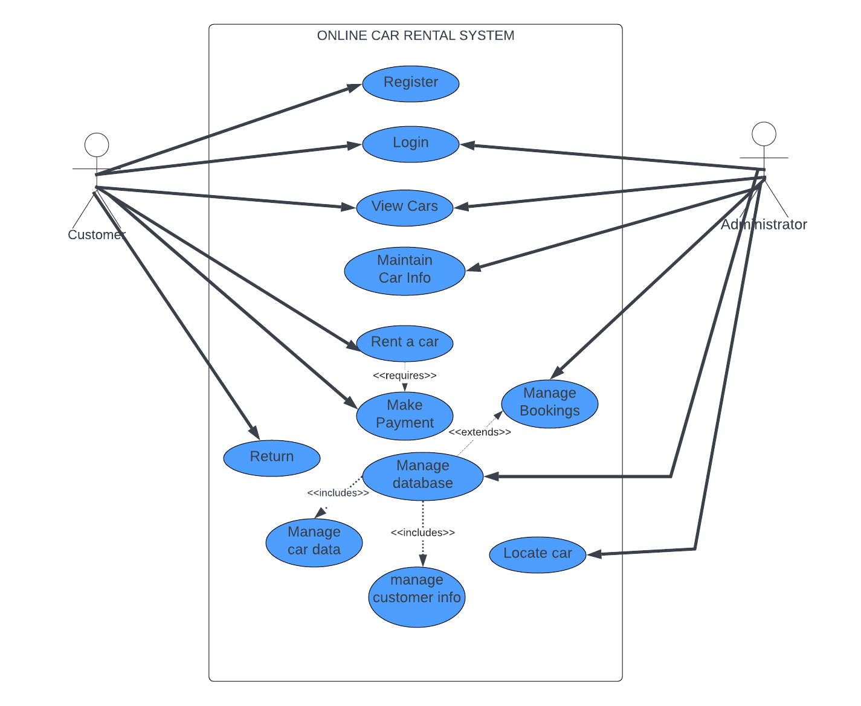

**EXAMPLES OF DATA, QUESTIONNAIRES AND FACT-FINDING TECHNIQUES USED**

1. Interview for System Development

Interviewee: Mudau Melton

Location: Johannesburg

Time: 12:00

Purpose of the Interview: To gain insights from the system owner regarding their vision, goals, constraints, and expectations for the car rental system project.

|  |  |  |
| --- | --- | --- |
| **Time Allocated** | **Interview Question** | **User** |
| 3 Minutes | State the purpose of the interview and explain what the information will be used for. |  |
| 5 Minutes | Can you provide an overview of your vision for the car rental system project and the objectives you aim to achieve? | We see our car rental system project aiming to build an application that makes the rent procedure quicker, easy and understandable for users while providing operational optimization. Our objectives are simple: reducing the reservation stress, fully sorting the fleet management and increasing the client satisfaction. |
| 6 Minutes | How do you see the system that we propose being able to alleviate challenges you currently identified in the car rental business? | We've found out that we've been facing difficulties because of ineffective reservation process, underutilization of our rental fleet, and low level of service quality. The solution is supposed to defeace these problems and to do so it will automate processes, optimize fleet management, and to improve service delivery |
| 3 Minutes | Is it possible to specify precisely the whole set of car rental system and essential restricts and limits? | The project scope involves the implementation of a complex software for management of rentals. The limitation are the budgetary ceilings, the necessity to apply the already existing resources, and ensuring the offline capability in areas where the internet is not available |
| 5 Minutes | Outline your major targets that you want to achieve with the car rental system and what you will do to define effectiveness. | We are setting objectives of streamlining the processes, guiding customer care, and operating revenue growth through ensuring optimal reservation processing time, fleet utilization rate, as well as customer feedback score quantitatively |
| 5 Minutes | What are the main requirements and key expectations for the functionality and features which your wanted car rental system should have? | It is expected that the system is able to offer easy reservation processes, whole lifecycle management, and extensive reporting and analytics features. Some requirements are data integration with existing systems and intuitive user interface. |
| 3 Minutes | How about summarizing the planned duration of the project and the most important targets you expect to achieve? | For the initial version to be implemented within six months, we have planned a series of milestones such as design, development, user training, testing, deployment. We will then continue with iterative improvements that will be based on feedback and performance metrics |
| 2 Minutes | How do you propose ongoing support and maintenance of the rental system to be carried out after it is deployed? | Thus our plan includes the deployment of a responsible support team and the monitoring of system performance and user feedback on a regular basis to make necessary improvements and keep the app functional and attractive |
| 2 Minutes | Is there something else that you would like to talk about or any points that should be kept in mind for the car rental systems project? | I would like to emphasize the communication and collaboration venue throughout the project. Be it clear communication and alignment between stakeholders or not, the success will depend on this. |

1. Questionnaire

We kindly request a few moments of your time to complete this survey

1. On a scale of 1 to 5, how would you rate your overall experience with the current system?

1.

2 .

3.

4.

5.

2. How satisfied were you with the ease of the reservation process?

1.

2 .

3.

4.

5.

3. How satisfied were you with the quality and condition of the vehicle you rented?

1.

2 .

3.

4.

5.

4. How would you rate the professionalism and helpfulness of our staff during your rental experience?

1.

2 .

3.

4.

5.

5. Were the vehicle options available to you satisfactory?

1.

2 .

3.

4.

5.

6. Do you feel that the rental price you paid was fair and represented good value for money?

1.

2 .

3.

4.

5.

7. How likely are you to recommend the current system to a friend or colleague?

1.

2 .

3.

4.

5.

Car Rental System Research

**We asked an employee of 5 car rental systems these questions**

1. On a scale of 1 to 3, please rate your overall experience with the current car rental system of your company.

1 - Dissatisfied

2 - Neutral

3 – Satisfied

1. How would you rate the ease of use of the car rental system of your company in performing your tasks?

1 - Difficult

2 - Neutral

3 – Easy

Functionality:

1. Does the current system meet your needs effectively in terms of functionality?

1 - No

2 - Partially

3 - Yes